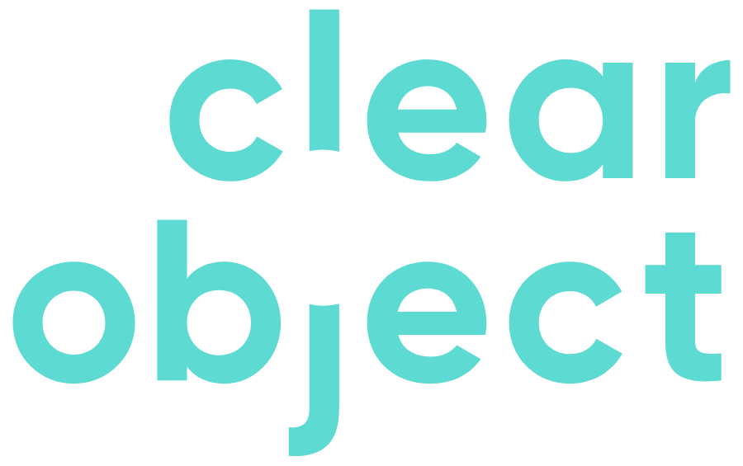

Rent the Runway Statement of Work:
Digital Thread|| IoT Platform

Feb 26, 2026

PROJECT OVERVIEW

Background
This Statement of Work ("SOW") is effective on the date of last signature below ("Effective Date") by and between ClearObject, Inc. with an address at 11634 Maple Street, Suite 200, Fishers, IN, 46038 (hereinto referred to as “ClearObject”), and Rent the Runway with an address at 10 Jay St., New York, NY 11202 (hereinto referred to as “Customer” or “Rent the Runway” or “RTR”).
This SOW and the pricing incorporated within Fees for the proposed Services and Deliverables will be valid for thirty (30) days, or until 03/31/2026 (“Valid Proposal Period”). After the expiration of the Valid Proposal Period, this SOW will not be exercisable and a new SOW proposal will need to be created if the Customer intends to pursue these Services and Deliverables.

Executive Summary
This SOW outlines a time and materials engagement, capped at $101,600 over 12 weeks, to deliver three core operational capabilities for Rent the Runway (RTR): Dryer Intelligence, iConnect Integration Strategy, and Operational Visualization via a Looker dashboard. Deliverables are subject to requirements discovered and RTR's prioritization. Built on Google Cloud Platform (GCP) with cloud-native architecture, the platform will enable RTR's operations team to monitor equipment, identify anomalies, optimize throughput, and improve efficiency through data-driven decisions.

Project Assumptions & Dependencies
Successful 12-week delivery is contingent on the following assumptions:
- Facility Access: ClearObject granted all necessary access (facility, VPN, systems) within 5 business days of request.
- RTR Resource Availability: Designated RTR SMEs are available for 4 hours/week for validation and decision-making.
- Appendix C Questionnaire: Complete responses provided within 10 business days of SOW execution. Delays may affect scope feasibility.
- Network & Security Approvals: RTR IT completes required configurations (VLAN, firewall, SSO, API) as specified in the project plan; ClearObject provides specifications.
- Hardware Procurement Timeline: If RTR self-procures, hardware must be delivered to EWR per ClearObject's project timeline. Delays extend integration/testing.
- Third-Party System Access: RTR facilitates access to Union/iConnect vendor support for Deliverable 2 integration, if required.
- Hardware Procurement Lead Time Accountability: Vendor lead times are estimates. ClearObject is not liable for vendor-caused delays (supply chain, backorders), which are considered Force Majeure. ClearObject will select best-option vendors, place prompt orders, monitor status, and offer contingencies. RTR assumes schedule risk if they select an option ClearObject flagged as having longer lead times.
Impact of Delays: RTR delays totaling >10 business days may extend the timeline or require scope reduction. Delays >15 business days may lead to engagement pause, requiring 2 weeks' notice and mutual agreement to restart.

SCOPE OF WORK

Deliverable 1: Dryer Intelligence Solution
Objective: Deploy an IoT-based monitoring system for fifteen (15) industrial dryers at RTR's EWR facility to provide real-time operational visibility and performance analytics.
Capabilities:
- Real-Time Sensor Data Collection:
  - Temperature and humidity monitoring during drying cycles
  - Vibration analysis to detect cycle start, completion, and anomalies
  - Cycle completion detection (automated notification when loads are ready)
  - Environmental condition tracking for quality control
- Edge-to-Cloud Data Pipeline:
  - Secure MQTT-based communication from sensors to Google Cloud Platform
  - Data ingestion into Google Cloud Pub/Sub
  - Real-time processing and storage in BigQuery
  - Historical data retention for trend analysis
- Compliance & Documentation:
  - Adherence to facility safety requirements for hazardous locations (if applicable per Appendix C)
  - Installation documentation and operational runbooks
  - Sensor calibration procedures
Technical Architecture:
- IoT sensors mounted on/near dryers (temperature, humidity, vibration/accelerometer)
- Industrial IoT gateway for local data aggregation and edge processing
- Secure cloud connectivity via cellular (LTE/5G) or facility network
- Google Cloud IoT Core or MQTT broker for device management
- Data pipeline: Pub/Sub → Dataflow/Cloud Functions → BigQuery
Note: The direct procurement costs of the physical hardware sensors and gateways are excluded from this fee and will be handled per Section 5.1.2 (Hardware Procurement).
ClearObject will deliver, one (1) production-ready dryer monitoring solution, collaboratively selected by RTR from three alternatives presented by ClearObject in Weeks 1-2. The comparison document will evaluate options based on cost, accuracy, installation complexity, and hazardous location compliance. By Week 3, RTR must select the architecture (A/B/C), procurement method, and approve the hardware budget via email.

Deliverable 2: iConnect Integration Strategy & Implementation
Objective: Connect to Rent the Runway's (RTR) Union iConnect dry cleaning machine system to feed operational data into the unified analytics platform.
Capabilities:
- System Discovery: Assess iConnect architecture, APIs, and data access for machine status (cycle state, errors, runtime). Determine network strategy (local, VPN, or API).
- Data Integration: Build an automated pipeline for data extraction, normalization to RTR's model, and ingestion into Google Cloud BigQuery, including error handling.
- Visibility: Provide real-time/near-real-time machine status and historical data for utilization analysis via the Looker dashboard.
Technical Approach: Deploy a network polling service/bridge to integrate with iConnect's interfaces (REST API, DB replication, or file export) and pipe data to BigQuery.
Scope Note: iConnect documentation is limited. Scope assumes basic HTTP/REST API access, no encrypted protocol reverse-engineering, and polling intervals. Complex integrations (e.g., custom protocol decoding, vendor NDAs) require a Week 6 scope impact assessment.

Deliverable 3: Operational Visualization Dashboard (Looker)
The project aims to build a centralized operational dashboard in Looker Studio for Rent the Runway (RTR). This dashboard will provide RTR's operations team with real-time visibility into dryer and dry cleaning equipment performance.
Key Dashboard Features:
- Equipment Status: Real-time, color-coded status (running, idle, alert).
- Performance Metrics: Throughput, utilization, temperature/humidity trends, and cycle duration analytics.
- Alert Management: Active and historical alerts with severity and drill-down capability.
- Historical Analysis: Trend charts and comparative analysis for management reports.
Technical/Scope: Uses Looker Studio connected to BigQuery, with RBAC and an optimized refresh rate (5-15 mins). It must have an intuitive, mobile-friendly UX that surfaces actionable insights. Data sources include equipment sensor data (Deliverable 1 & 2) and cloud pipelines. The scope is limited to standard visualizations; advanced features like predictive modeling are excluded.

OUT OF SCOPE
The following items are explicitly excluded from this SOW and require separate agreements:
- Additional Equipment: Monitoring beyond the 15 specified dryers and iConnect dry cleaning machines (e.g., washers, pressers, conveyors, HVAC).
- Predictive Maintenance: Advanced ML models for predictive failure analysis/scheduling (focus is on real-time monitoring/alerting).
- Mobile Apps: Native iOS/Android apps (dashboard is web-based/mobile-responsive).
- ERP/WMS Integration: Integration beyond the iConnect system (e.g., SAP, Oracle, WMS).
- Physical Installation Labor: Performed by RTR's team/contractors; ClearObject provides specs/remote support.
- Long-Term Managed Services: Ongoing support beyond the 12-week delivery period (post-project support negotiable).
- Hardware Costs: Billed separately (Section 5.1.2).
- Network Upgrades: Installation of new network drops, switches, or facility-wide equipment.
- Custom Reporting: Ad-hoc reports beyond the standard Looker dashboard (can be added via Change Order).

DELIVERY ROADMAP (12 WEEKS)
The project is structured with parallel work streams to maximize progress independent of hardware procurement lead times. The roadmap below shows concurrent activities across three tracks:

TRACK 1: Infrastructure & Foundation (Weeks 1-8)
Not hardware-dependent; proceeds in parallel

Phase 1A: Digital Foundation (Weeks 1-4)
- GCP project setup, network configuration, security policies
- MQTT broker deployment and testing
- BigQuery schema design and table creation
- Auth0/SSO integration and RBAC configuration
- Development environment provisioning
- Milestone: Secure cloud environment operational

Phase 1B: Data Pipeline Architecture (Weeks 5-8)
- Data ingestion pipeline development (Pub/Sub → BigQuery)
- API endpoints for sensor data reception
- Data normalization and transformation logic
- Monitoring and alerting infrastructure
- Hardware Independence: Uses synthetic test data (simulated sensor JSON payloads)
- Milestone: End-to-end data flow validated with test data

TRACK 2: Dryer Intelligence Hardware (Weeks 1-12)
Critical path; schedule contingent on procurement lead times

Phase 2A: Hardware Selection & Procurement (Weeks 1-7)
- Weeks 1-2: Research three alternative sensor architectures; present comparison
- Week 3: RTR selects approach and approves hardware budget
  - CRITICAL DECISION POINT: Procurement initiated immediately
- Weeks 3-7: Vendor procurement (assumes 4-5 week lead time)
  - ClearObject monitors delivery status weekly
  - If delays forecasted, trigger Scenario planning per Section 5.1.2
- Milestone: Hardware delivered to EWR facility

Phase 2B: Hardware Integration (Weeks 6-12)
- Weeks 6-7: Bench testing of sensors (if early delivery)
  - Calibrate temperature/humidity against reference instruments
  - Validate vibration FFT algorithms for cycle detection
  - Test MQTT connectivity and data transmission
- Weeks 8-9: Physical installation (RTR facilities team or union labor)
  - ClearObject provides "over-the-shoulder" remote support
  - Mount sensors on 15 dryers per installation plan
  - Run cabling and connect to network gateway
- Weeks 10-11: Live integration testing
  - Validate real sensor data flowing to BigQuery
  - Tune cycle detection thresholds based on actual dryer behavior
  - End-to-end alert testing (trigger over-temp, verify alert fires)
- Week 12: User acceptance testing
- Milestone: 15 dryers transmitting production data
Contingency: If hardware delayed beyond Week 8, implement Scenario 3 per Section 5.1.2 (timeline extension, scope reduction, or phased delivery)

TRACK 3: iConnect Integration (Weeks 4-10)
Independent of dryer hardware; can complete even if Track 2 delayed

Phase 3A: iConnect Discovery (Weeks 4-5)
- Deep investigation of iConnect system architecture
- Vendor engagement (Union technical support) for API access
- Network connectivity strategy (VPN, polling service architecture)
- Data schema mapping (iConnect codes → RTR standard)
- Week 5 Gate: Go/No-Go decision based on complexity assessment
  - If feasible: Proceed to Phase 3B
  - If excessive complexity: Present Scenario 3 options to RTR

Phase 3B: Pipeline Implementation (Weeks 6-8)
- Polling service development (extract iConnect machine status)
- Data normalization implementation
- BigQuery staging table population
- Error handling and retry logic
- Hardware Independence: Uses iConnect system in facility; no dependency on new dryer sensors

Phase 3C: Validation & Testing (Weeks 9-10)
- 48-hour continuous monitoring test
- Data quality validation (completeness, accuracy)
- Pipeline monitoring and alerting configuration
- Milestone: iConnect data flowing reliably to BigQuery

TRACK 4: Looker Dashboard (Weeks 6-12)

Phase 4A: Design (Wk 6-7)
- Wireframe, mockup, RTR review/approval. Configure Looker, connect BigQuery to iConnect (real data, Wk 9) and simulated dryer data (until hardware).

Phase 4B: Development (Wk 8-10)
- Wk 8-9: Build core views with available data: machine status (real iConnect), placeholder dryer tiles (simulated/early hardware), alert history, basic KPIs.
- Wk 10: Integrate dryer intelligence (once hardware live): real sensor feeds replace simulated data, add temp/humidity trends, cycle metrics, vibration analysis.

Phase 4C: UAT & Refinement (Wk 11-12)
- UAT with RTR operators/managers. Performance optimization. Final adjustments. Milestone: Production-ready dashboard with all real data.
- Contingency: If dryer hardware is delayed, the dashboard is accepted with complete iConnect integration (Deliverable 2) and simulated dryer data for UI/UX testing. Real dryer data integrates in a follow-on mini-project.

PARALLEL WORK ENABLES FLEXIBILITY
- ~60% of scope (Tracks 1, 3, 4) proceeds despite potential hardware delays.
- Working deliverables (iConnect integration + dashboard with partial data) are available even if dryer hardware is delayed.
- Efficient resource use (no team idleness waiting for parts).
- Clear decision points (Week 3 procurement, Week 5 iConnect gate, Week 8 hardware contingency trigger).
Weekly Status Reporting: ClearObject will report weekly on:
- Track 2 hardware delivery forecast.
- Risk flags if procurement threatens the Week 8 threshold.
- Contingency plan activation status.

Risk Management & Contingency Plans
Risk | Impact | Probability | Mitigation
Hardware Lead Times (>6 Weeks) | Schedule delay, budget overrun ($6,350/wk), quality issues. | Medium-High (40-60%) | Expedite vendor research, prioritize lead time (30% weight), immediate procurement (Week 3) with expedited shipping.
iConnect System Complexity | Excessive budget consumption/forced prioritization. | Medium-High (proprietary docs) | Deep discovery (Wks 5-6) then hard stop. Offer RTR options: simplify, defer to Phase 2, or budget increase.
RTR Approval Delays | Work stalls, timeline extension (>12 wks). | Low-Medium | Identify decision-makers early, schedule bi-weekly review holds. Delays >10 days extend timeline day-for-day.
Facility Access/Safety Delays | Delayed on-site work. | Low (remote-first) | Emphasize remote configuration; pre-coordinate facilities access; assume remote support for install.

FEES AND EXPENSES

Billing and Payment Terms
This engagement operates on a Time & Materials basis with a budget cap.

Core Team Time & Materials Structure
Blended Hourly Rate: $188.15 per hour
This rate covers the following team composition working on project deliverables:
- Data Scientist: Lead model development and optimization.
- Principal: Oversee project execution and client communication.
- Backend Developer: Implement and integrate backend components.
- Full Stack Developer: Develop and maintain the full-stack application for the vision platform.
- Technical Project Manager: Ensure timely delivery, manage resources, and handle day-to-day operations.
- SME | Operations Engineer: Manufacturing subject matter expert and strategist on operation.
Budget Cap: $101,600 (equivalent to 540 hours over 12 weeks)
Billing Cycle: Every 4 weeks (3 invoices total)
Invoice Schedule:
- Invoice 1 (Week 1): $33,866 (covering Weeks 1-4)
- Invoice 2 (Week 5): $33,866 (covering Weeks 5-8)
- Invoice 3 (Week 9): $33,868 (covering Weeks 9-12)
Payment Terms: Net 30 days from invoice date
Not-to-Exceed Provision:
ClearObject will not exceed the $101,600 budget cap without prior written approval from RTR. If project tracking indicates the budget will be insufficient to complete all deliverables, ClearObject will notify RTR no later than Week 8 with:
- Current progress assessment
- Estimated effort to complete each remaining deliverable
- Three options for RTR consideration:
  - Option A: Prioritize deliverables (RTR selects which to complete, which to defer)
  - Option B: Approve budget increase at the same $188.15/hour rate for additional weeks
  - Option C: Extend timeline at reduced weekly rate (reallocate partial resources)

Hardware Procurement & Pass-Through Costs
All IoT hardware, sensors, gateways, cabling, mounting equipment, and related materials required for Deliverable 1 (Dryer Intelligence) are excluded from the $101,600 core team budget and will be handled as follows:
ClearObject Procurement
- ClearObject orders hardware on RTR's behalf
- RTR pays actual vendor cost + 20% for:
  - Procurement administration and vendor coordination
  - Configuration, integration of custom firmware/references to MQTT, and bench testing before shipment to EWR
- ClearObject invoices separately upon delivery to RTR facility
- Payment terms: Net 30 days from invoice date

Hardware Budget Estimate:
$25,000 - $35,000 total for 15-dryer deployment, including:
- IoT gateway(s): ~$2,000 - $3,000
- Per-dryer sensor packages (temp/humidity, vibration, mounting): $1,500 - $2,000 × 15
- Cabling, conduit, and installation supplies (In RTR’s procurement scope): ~$3,000 - $5,000

Important Notes:
- Estimate based on current market pricing for industrial IoT sensors with Class I Division 2 hazardous location ratings
- Actual costs depend on final specifications developed during Weeks 1-3 per Appendix C requirements
- Costs may increase if facility assessment reveals need for explosion-proof enclosures, intrinsically safe barriers, or specialized mounting hardware
- RTR must approve final hardware specifications and budget in writing (email acceptable) before ClearObject initiates procurement under Option B

Procurement Timeline & Critical Path:
- Week 2: Hardware specifications finalized
- Week 3: RTR selects Option A or B and approves budget
- Week 3-7: Procurement and delivery (4-5 week lead times typical for industrial-grade sensors with hazardous location certifications; up to 6 weeks if custom configurations required)
- Week 8+: Physical installation and integration testing

Intellectual Property

Background Intellectual Property
ClearObject possesses and may utilize certain pre-existing intellectual property, including but not limited to its proprietary methodologies, analytical frameworks, software tools, algorithms, data processing techniques, and general know-how related to data analytics, AI/ML model development, process optimization, and manufacturing intelligence, developed or acquired by ClearObject independently of this SOW (collectively, "Background IP"). All rights, title, and interest in and to such Background IP shall remain solely with ClearObject.
To the extent that ClearObject’s Background IP is incorporated into or is necessary for RTR’s use of the Deliverables (as defined below) provided under this SOW, ClearObject grants RTR a non-exclusive, non-transferable, royalty-free, perpetual license to use such Background IP solely as an integral part of, and for the purpose of utilizing, such Deliverables for RTR's internal business purposes. RTR shall not, and shall not permit any third party to, reverse engineer, decompile, or disassemble any Background IP of ClearObject.

Ownership of Deliverables
As used herein, "Deliverables" shall mean the custom-developed machine learning model artifacts, the labeled image datasets, and all related documentation, test reports, analyses, and presentation materials developed by ClearObject specifically for RTR and delivered to RTR pursuant to this SOW. Subject to RTR's full payment of all fees due under this SOW and ClearObject's rights in its Background IP, RTR shall own all rights, title, and interest in and to the Deliverables.
Notwithstanding the foregoing, ClearObject shall retain ownership of its Background IP. ClearObject shall also have the right to use its general skills, know-how, experience, and any ideas, concepts, or techniques developed or learned during the performance of the Services under this SOW, provided that in doing so, ClearObject does not use or disclose any of RTR's Confidential Information (as defined below).
For the avoidance of doubt, "Deliverables" shall specifically include any and all custom-developed machine learning models, algorithms, and related software artifacts created by ClearObject for RTR under this SOW. Upon full payment of all fees due, RTR shall own all rights, title, and interest in and to these custom-developed models. ClearObject shall retain no rights to resell, reuse, redeploy, or otherwise transfer these specific custom Deliverables to any other client or third party.
For clarity, ClearObject retains the unrestricted right to use generalized learnings, architectural patterns, and non-customer-specific techniques developed during the engagement, provided that no Rent the Runway Confidential Information or custom Deliverables are disclosed or reused.

Confidentiality and Trade Secrets
(a) Definition of “Confidential Information”: Means any information disclosed by one party (the "Disclosing Party") to the other party (the "Receiving Party"), either directly or indirectly, in writing, orally, or by inspection of tangible objects, which is designated as "Confidential," "Proprietary," or some similar designation, or which should reasonably be understood to be confidential given the nature of the information and the circumstances of disclosure. RTR's Confidential Information includes, but is not limited to, its operational data, manufacturing processes, business plans, and environment details. ClearObject's Confidential Information includes, but is not limited to, its Background IP, proprietary methodologies not generally known, and the terms of this SOW.
(b) Obligations: The Receiving Party agrees to: (i) use the Confidential Information of the Disclosing Party solely for the purpose of performing its obligations or exercising its rights under this SOW; (ii) not disclose such Confidential Information to any third party without the prior written consent of the Disclosing Party, except as expressly permitted herein or to employees or contractors who have a need to know and are bound by confidentiality obligations at least as restrictive as those set forth herein; and (iii) protect such Confidential Information from unauthorized use and disclosure using the same degree of care it uses to protect its own confidential information of like nature, but in no event less than a reasonable degree of care.
(c) Exclusions: Confidential Information does not include information that: (i) is or becomes publicly known through no wrongful act of the Receiving Party; (ii) was in the Receiving Party’s lawful possession prior to disclosure by the Disclosing Party and not subject to a confidentiality obligation; (iii) is independently developed by the Receiving Party without use of or reference to the Disclosing Party's Confidential Information; or (iv) is rightfully received by the Receiving Party from a third party without restriction and without breach of any confidentiality obligation.
(d) Required Disclosure: If the Receiving Party is compelled by law or a court order to disclose Confidential Information of the Disclosing Party, it shall provide the Disclosing Party with prompt written notice thereof (to the extent legally permitted) so that the Disclosing Party may seek a protective order or other appropriate remedy.

Unauthorized Use and Infringement
Each party agrees that any unauthorized use, reproduction, distribution, display, modification, creation of derivative works, or disclosure of the other party's Intellectual Property (including Background IP and Confidential Information) without express written consent constitutes a violation of the other party's intellectual property rights. Each party reserves the right to pursue all available legal remedies to protect its rights, including but not limited to seeking injunctive relief, monetary damages, and any other appropriate remedies under the law.

WARRANTIES AND LIMITATIONS OF LIABILITY

Limited Warranty
ClearObject warrants that: (a) The Services will be performed in a professional and workmanlike manner consistent with industry standards. (b) ClearObject has the right to enter into this SOW and perform the Services without violating any third-party rights. (c) The Deliverables will substantially conform to the Acceptance Criteria in Appendix B for 30 days after acceptance. ClearObject's sole obligation for breach of this warranty is to re-perform non-conforming work at no additional charge.
Warranty Exclusions: This warranty excludes: (i) defects caused by RTR modifications, (ii) third-party hardware failures, (iii) GCP service outages, (iv) changes to RTR's network/security environment.

Disclaimer
EXCEPT AS EXPRESSLY SET FORTH IN SECTION 7.1, CLEAROBJECT MAKES NO OTHER WARRANTIES, EXPRESS OR IMPLIED, INCLUDING ANY IMPLIED WARRANTIES OF MERCHANTABILITY, FITNESS FOR A PARTICULAR PURPOSE, OR NON-INFRINGEMENT. CLEAROBJECT DOES NOT WARRANT THAT THE SERVICES WILL BE UNINTERRUPTED OR ERROR-FREE.

Limitation of Liability
TO THE MAXIMUM EXTENT PERMITTED BY LAW, CLEAROBJECT'S TOTAL LIABILITY ARISING OUT OF OR RELATED TO THIS SOW SHALL NOT EXCEED THE TOTAL FEES PAID BY RTR UNDER THIS SOW IN THE TWELVE (12) MONTHS PRECEDING THE CLAIM.
IN NO EVENT SHALL CLEAROBJECT BE LIABLE FOR ANY INDIRECT, INCIDENTAL, CONSEQUENTIAL, SPECIAL, OR PUNITIVE DAMAGES, INCLUDING LOST PROFITS, LOST DATA, OR BUSINESS INTERRUPTION, EVEN IF ADVISED OF THE POSSIBILITY OF SUCH DAMAGES.
Exceptions: The limitations in this Section 7.3 do not apply to: (i) RTR's payment obligations, (ii) either party's indemnification obligations, or (iii) damages caused by either party's gross negligence or willful misconduct.

Entire Agreement
As it relates to this statement of work (and Appendix A hereto, which is incorporated herein) and the Agreement contain the entire agreement of the parties regarding the subject herein, and supersede all prior or contemporaneous negotiations, discussions, understandings or agreements between the parties relating thereto. Neither party has relied on any such negotiations or discussions. By entering into this SOW, Customer is not relying upon any representation made by or on behalf of ClearObject that is not specified in this SOW, including, without limitation, the actual or estimated completion date, number of hours to provide any of the Services, charges to be paid, or the results of any of the Services to be provided under this SOW.
Except as amended by this SOW, all other terms and conditions of the Agreement shall continue in full force and effect. Any amendment to this SOW must be in writing and signed by the authorized representatives of both parties to be effective. This SOW may be executed in counterparts, each of which is an original, and together all parts are one instrument.
By the signature of each party's authorized representative below, the parties execute this SOW:
Agreed to: |  | Agreed to:
Rent the Runway |  | ClearObject Inc.
10 Jay St., New York, NY 11202 |  | 11634 Maple Street, Suite 200  Fishers, IN, 46038
By: |  | By:
Authorized signature - Customer |  | Authorized signature - ClearObject
Name (type or print) - Customer |  | Name (type or print) - ClearObject
Title - Customer |  | Title - ClearObject
Date Date

APPENDIX

Change Control Procedure
The following process will be followed if a change to this SOW is required,
- ClearObject and Customer may determine that it is necessary to exceed the scope and/or number of estimated hours for the Services as stated in the “Fees and Expenses” Section above. In such an event, Customer may authorize additional hours and funding by the written request of its SOW signatory. The request must reference the SOW number. Through the end of the calendar year (i.e., December 31) during which this SOW is originally executed, additional hours, funding, and End-Date extension may be requested in writing, and any changes that are needed will be done by way of Project Change Request Form (PCR). If accepted or initiated by ClearObject, such letter or e-mail will act as a Change Authorization to this SOW. All other requested changes will require execution of a Project Change Request as discussed below.
- A Project Change Request (PCR) will be the vehicle for communicating changes to this SOW. The PCR must describe the change, the rationale for the change and the effect the change will have on the project.
- A PCR must be signed by authorized representatives from both parties to authorize implementation of the change. Until a change is agreed to in writing, both parties will continue to act in accordance with the latest agreed version of the SOW.
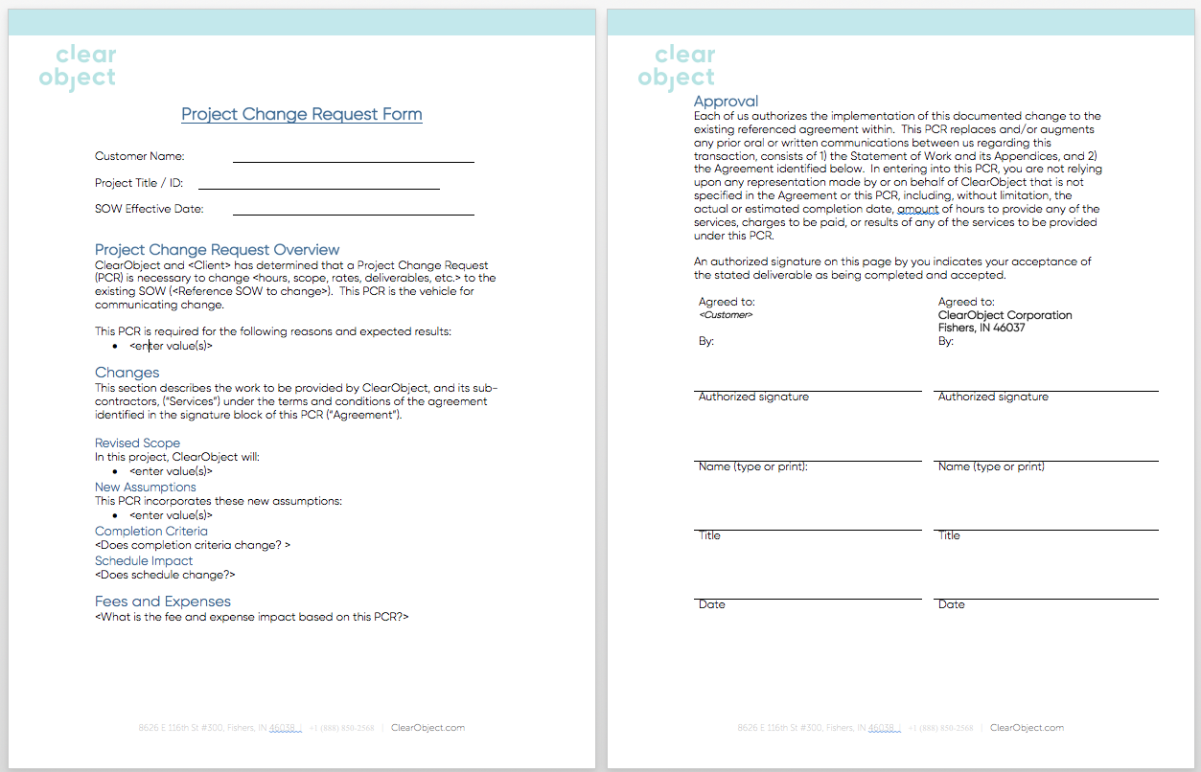
Illustration 1 – Sample Project Change Request Form

Project Deliverable Acceptance Procedure
The following process will be followed for any deliverables completed in this SOW,
- A Project Deliverable Acceptance Form (PDAF) will be the vehicle for communicating the completion of deliverables in this SOW. The PDAF must name the deliverable, the date it was delivered and any notes relevant to it.
- A PDAF must be signed by authorized representatives from both parties to authorize acceptance of the deliverable. ClearObject will provide written notice to Customer upon completion of the Deliverables in accordance with the terms of this SOW, and thereafter Customer shall test the Deliverables for compliance with this SOW (“Acceptance Criteria”). Customer shall complete testing within fifteen (15) business days, at which time it shall either provide written notice that it accepts the Deliverables, or provide written notice of the nonconformities with the Acceptance Criteria. In the event of notice of nonconformities with the Acceptance Criteria, ClearObject will promptly fix the Deliverables so that they conform to the Acceptance Criteria. Acceptance shall be deemed to occur upon the earlier of: Customer's first use of the Deliverables in a production environment; Customer's written acceptance; or fifteen (15) business days after ClearObject has notified Customer that it has completed the Deliverables if Customer does not provide written notice of nonconformance with the Acceptance Criteria during that time period.
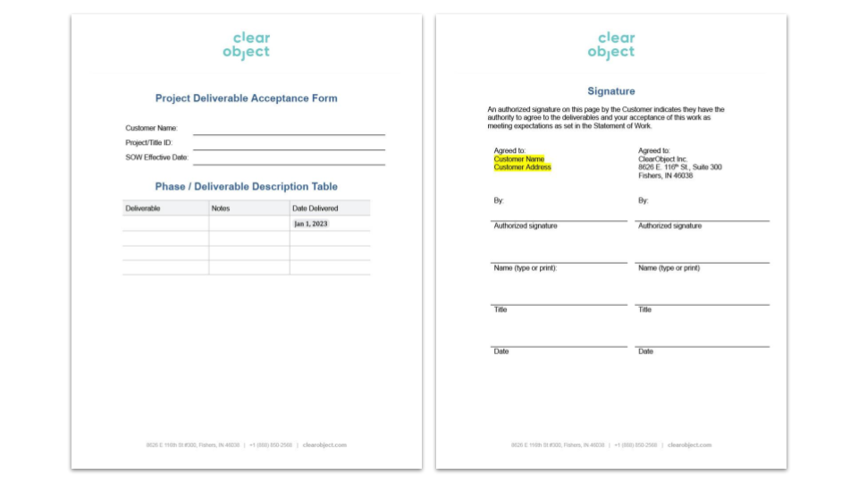
Illustration 2 – Sample Project Deliverable Acceptance Form

PROJECT DISCOVERY QUESTIONNAIRE
(MUST BE COMPLETED WITHIN 10 BUSINESS DAYS OF SOW EXECUTION)

CRITICAL: Timeline Dependency
Complete, detailed responses to all required questions are due within 10 business days of SOW execution (Section 1.3).
Failure to provide timely, complete answers will:
- Extend the 12-week timeline (project delayed until responses received).
- Increase the risk of exceeding the $101,600 budget.
- Potentially reveal scope complexities requiring re-prioritization.
ClearObject cannot finalize Deliverables 1, 2, or 3 (hardware, iConnect feasibility, dashboard design) without these answers.

Response Format:
RTR must submit responses in a separate document, quoting each question followed by the answer. "TBD" is unacceptable for \[REQUIRED\] questions. "Not applicable" or "No specific requirement" is acceptable for \[OPTIONAL\] questions.

Hands-On Investigation:
Some questions (electrical, hazardous areas, network) may require RTR to conduct on-site assessments or involve facilities/IT teams. ClearObject can provide a facility checklist or assist remotely/on-site (billable) if needed.

Application Infrastructure & Security
- Hosting Environment: Deployment of a containerized environment (e.g., GCP Cloud Run or GKE) to host the custom Looker Dashboard and data.
- Authentication & Authorization (Auth0/Cognito/SSO): Role-Based Access Control (RBAC) to mimic controls in place for GCP.
- State Database: A relational database (e.g., PostgreSQL) to store Machine Metadata (Asset Registry), IOT ingestion data, and iConnect data.

Data Ingestion Architecture
- MQTT Broker: A secure broker is needed to handle incoming messages from dryer IoT nodes.
- Time-Series Storage: High-speed storage for vibration, temperature, and humidity readings of the dryer intelligence IOT solution.
- GCP Pub/Sub Integration: To decouple the hardware data stream from the dashboard/application logic.

Rent the Runway Security & Architecture Requirements
To ensure the proposed solution is compliant with RTR’s enterprise standards, we require confirmation or documentation regarding the following security and architectural protocols:
- Network Security & Segmentation: Does the facility require the IoT Gateway and iConnect Bridge to operate on a segregated VLAN? If so, what is the approval process for whitelisting outbound traffic (specifically MQTT/HTTPS to Google Cloud) from these devices?
- Identity & Access Management (IAM): For the looker dashboard, does RTR require integration with an existing corporate Identity Provider (e.g., Okta, Azure AD, Google Workspace) via SAML/SSO, or will a standalone Auth0 user pool be sufficient for this deployment?
- Data Residency & Governance: Are there specific compliance requirements regarding where the machine data is stored (e.g., US-only regions) or how long granular sensor data (vibration/temperature) can be retained before archiving?
- Device Security Standards: Do deployed edge devices require specific firmware signing, disabled physical ports, or SOC2-compliant data encryption at rest?

IoT Hardware Requirements
To prevent deployment delays or safety violations, the IoT hardware selected for the dryer and duct monitoring solutions must be vetted against the following facility-specific standards:
- Hazardous Location Ratings: Given the proximity to dry cleaning solvents (perchloroethylene or alternatives), do any of the dryer sensors or gateways need to be Class I, Division 2 certified (Explosion Proof) or IP67 rated (Dust/Liquid ingress)?
- Environmental Operating Limits: What are the maximum ambient temperatures near the dryer exhaust vents? We must ensure the "Duct Monitoring" sensor packages are rated to withstand the radiant heat of the dryers (potentially >140°F) without signal degradation.
- Compliance & Certifications: Does RTR require hardware to carry specific regulatory marks beyond standard FCC/CE (e.g., UL, ASME, or OSHA-specific machine guarding requirements) before it can be attached to the exterior of the dryers?

IoT Installation Guidelines
To ensure a smooth physical installation that respects RTR’s operational cadence and labor policies, we need clarity on the following:
- Labor & Union Constraints: Does the NJ facility operate under union contracts that restrict third-party technicians from mounting sensors or running cabling? If so, must we utilize RTR internal facilities teams for the physical install, with ClearObject providing "over-the-shoulder" supervision?
- Maintenance & Spare Parts Strategy: For the "Duct Monitoring" and vibration sensors, what is the expectation for on-hand spares? Should the project budget include a "Crash Kit" (10% spare sensor inventory) kept on-site to minimize downtime if a sensor fails?
- Installation Windows: Can installation occur during active shifts (non-intrusive), or must it be scheduled during facility downtime/weekends to avoid Lockout/Tagout (LOTO) procedures on the dryers?
- Cable Routing: Are there existing conduits we can utilize for power/network cabling, or will surface-mounted raceways be required?

Quality Assurance & Testing Strategy
To ensure a robust and production-ready solution, a formalized testing strategy will be executed across all phases, beyond initial development testing and final UAT.
- Development/Unit Test: Local developer environments and CI/CD pipelines for automated unit and integration tests.
- Staging/Pre-Prod: A persistent, clean environment in GCP for end-to-end and performance testing, utilizing scrubbed or synthetic production data to simulate load.
- Production (Dry-Run): Where applicable, a subset of non-critical devices will be brought online first to validate data flow and core logic in a live setting before full rollout.

